user

User/admin

SearchFlight:

List of users bookings

signout

login

Username

Password

Create

Username

password

New Componemt

New Componemt

Flight 1 book

Booking form

New?create Account

New Componemt

New Component

New Componemt

New Componemt

All Bookings And Cancellations

Flight 1 edit del

Flight 2 edit del

Update Flight

1>List of Flights{here in this page}

2>Update Flight

3>Delete Flight

4> Report{list Of All Boookings}

Add Flights

ADMIN

signout

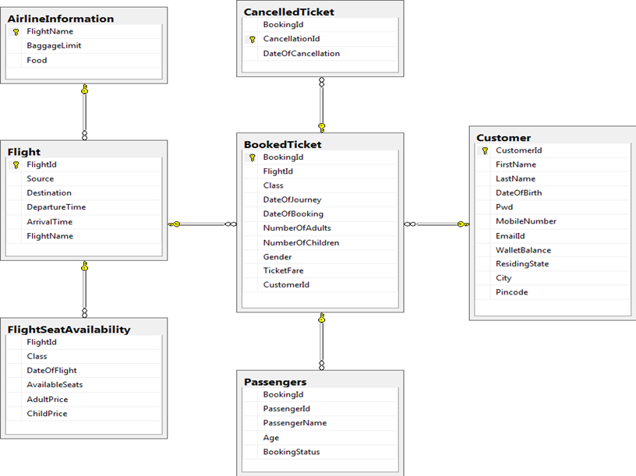

|  |
| --- |
| Customer |
| Name |
| Password |
|  |
|  |
|  |

1. s  
   Created Profile page Component
2. Made UI Changes
3. Implemented Authentication
4. Implemented Guards And Interceptors

Who will make ppt???